Skill Week-5 (V.SATHVIK,2520090097)

GET API - Retrieve all students
@app.get("/students") def get_students():

with engine.connect() as connection: result = connection.execute(
text("SELECT * FROM students")
)
students = result.mappings().all() return {
"message": "Students retrieved successfully", "students": students
}

What is shown on Swagger for above code-

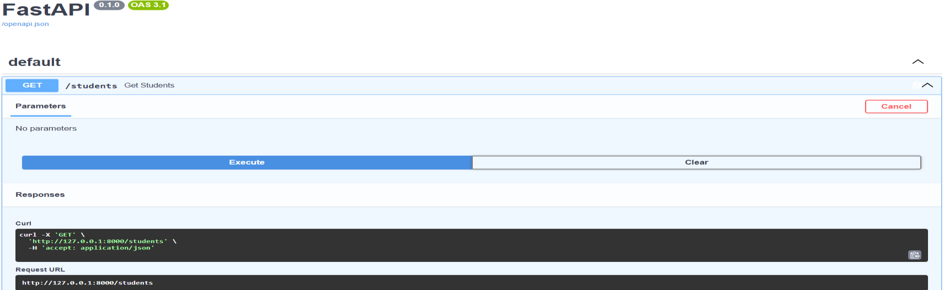

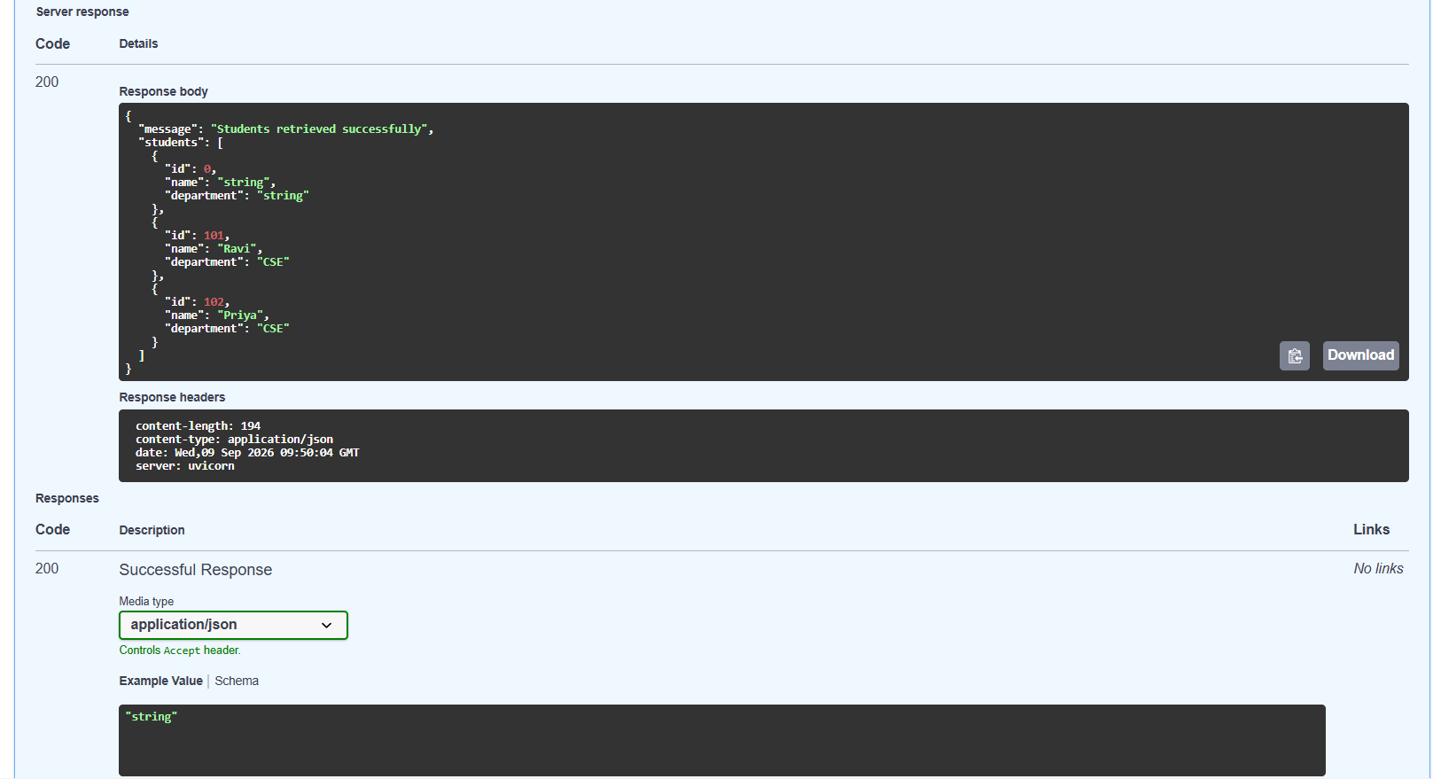

POST API - Add a new student

@app.post("/students")
def create_student(student: Student):

with engine.begin() as connection: connection.execute(
text("""
INSERT INTO students (id, name, department) VALUES (:id, :name, :department)
"""),
{
"id": student.id, "name": student.name,
"department": student.department
}
)

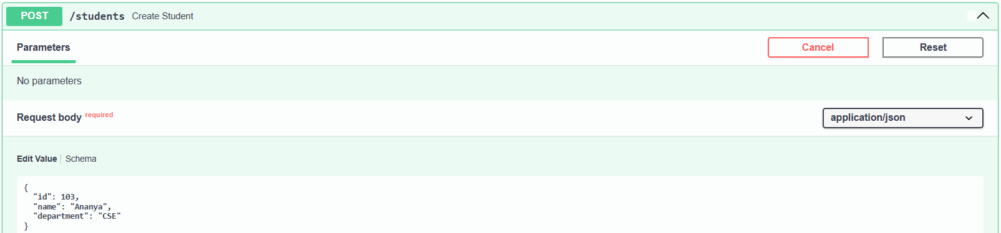
What is shown for above POST code on Swagger-

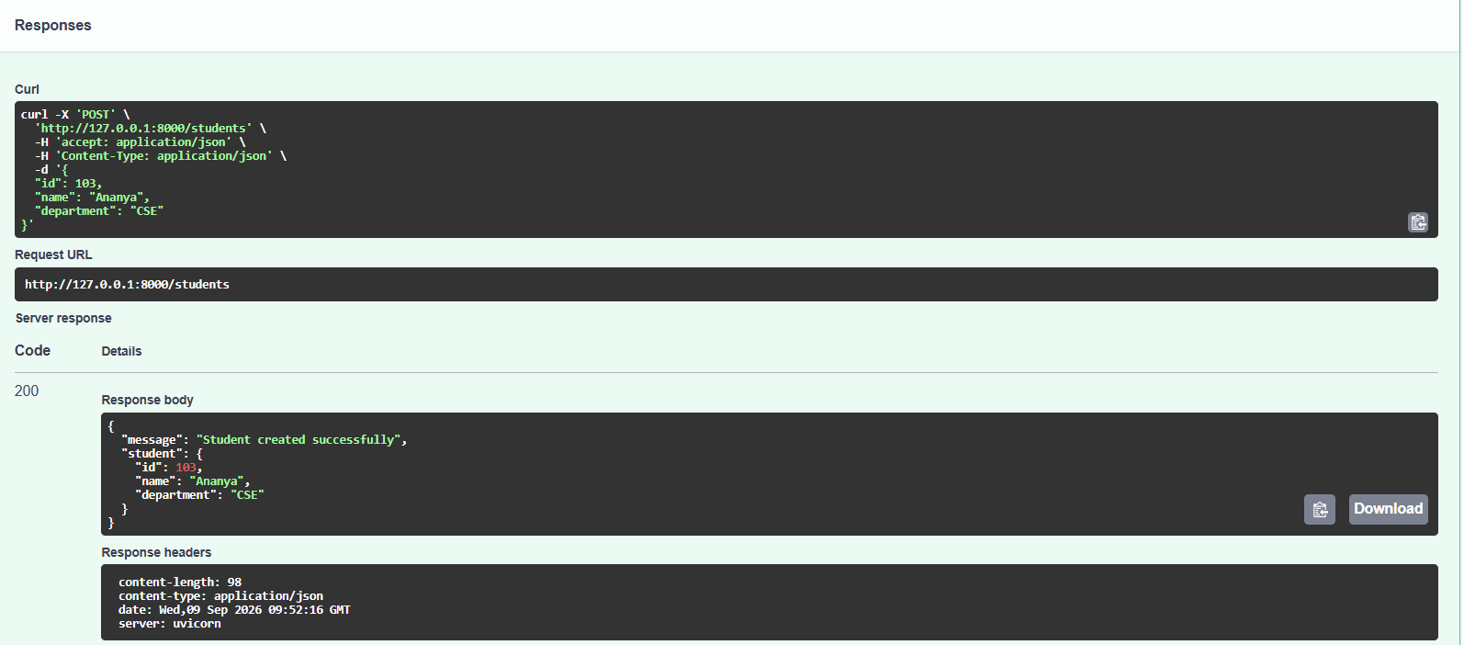

Before Posting Student Data:
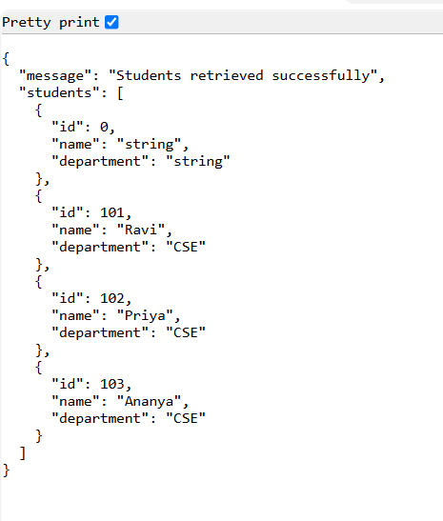

After posting student-104:
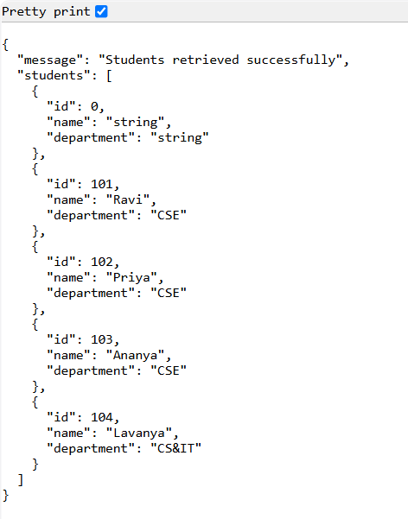

PUT - Update an existing student
@app.put("/students/{student_id}")
def update_student(student_id: int, student: Student): with engine.begin() as connection:
result = connection.execute( text("""
UPDATE students SET name = :name,
department = :department WHERE id = :student_id
"""),
{
"student_id": student_id, "name": student.name, "department": student.department
}
)

if result.rowcount == 0: return {
"message": "Student not found"
}

return {
"message": "Student updated successfully", "student": student
}

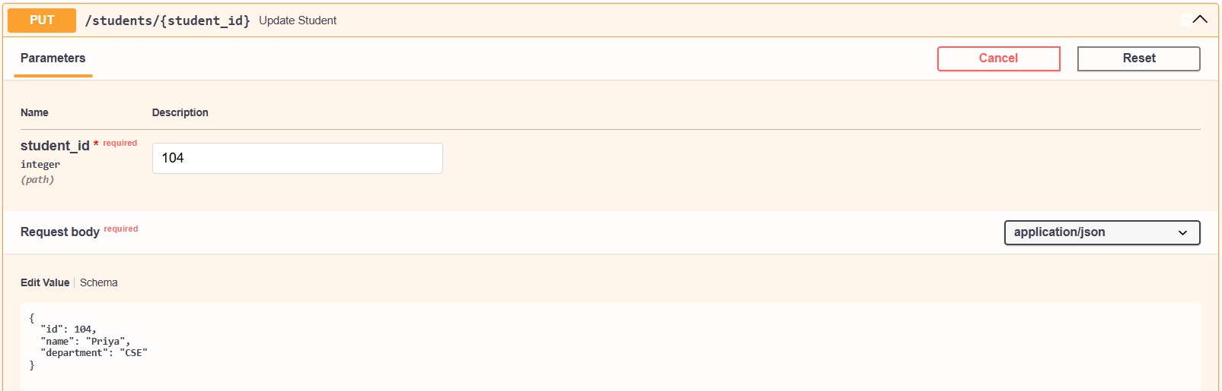
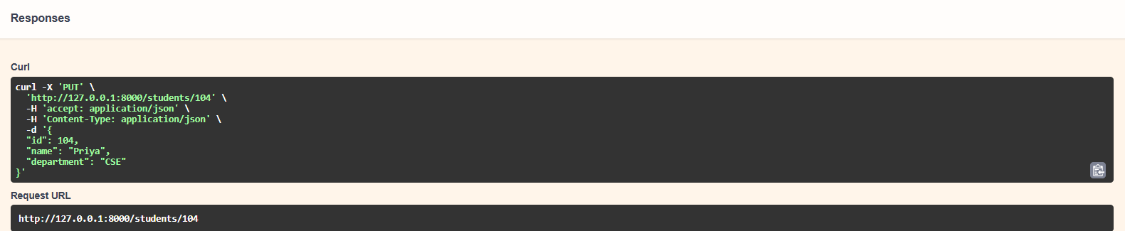

Output after editing using PUT:
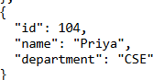

DELETE - Delete a student
@app.delete("/students/{student_id}") def delete_student(student_id: int):
with engine.begin() as connection: result = connection.execute(
text("""
DELETE FROM students WHERE id = :student_id
"""),
{
"student_id": student_id
}
)

if result.rowcount == 0: return {
"message": "Student not found"
}

Output:
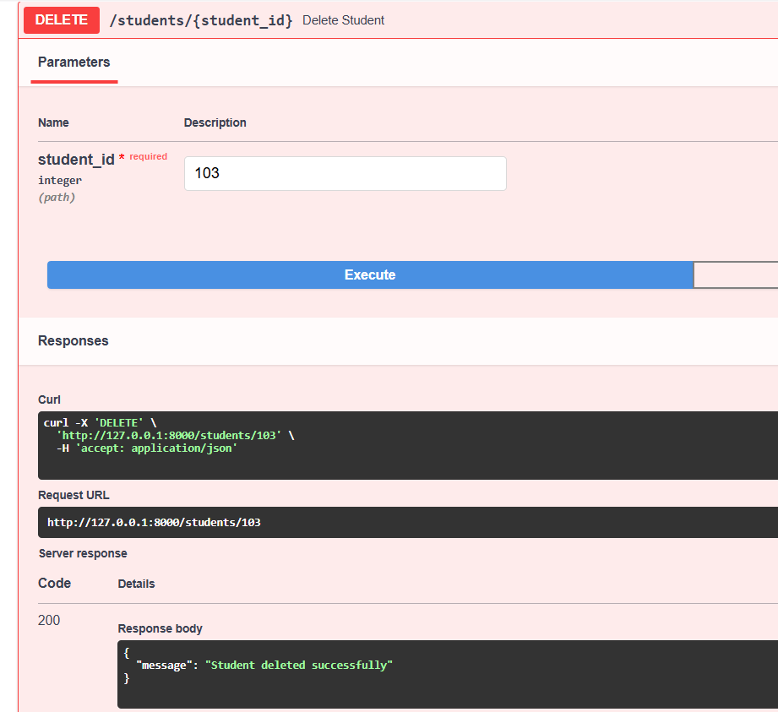

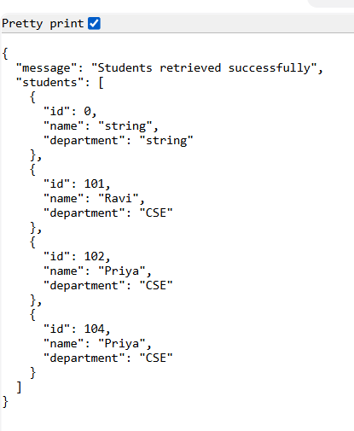

SQL Workbench Code:
CREATE DATABASE university; USE university;

CREATE TABLE students ( id INT PRIMARY KEY, name VARCHAR(100),
department VARCHAR(100)
);
SHOW DATABASES;
USE university;

INSERT INTO students (id, name, department) VALUES
(101, 'Ravi', 'CSE'),
(102, 'Priya', 'CSE');

SHOW TABLES;
SELECT * FROM students;

Workbench Output:
